VLAN Configuration

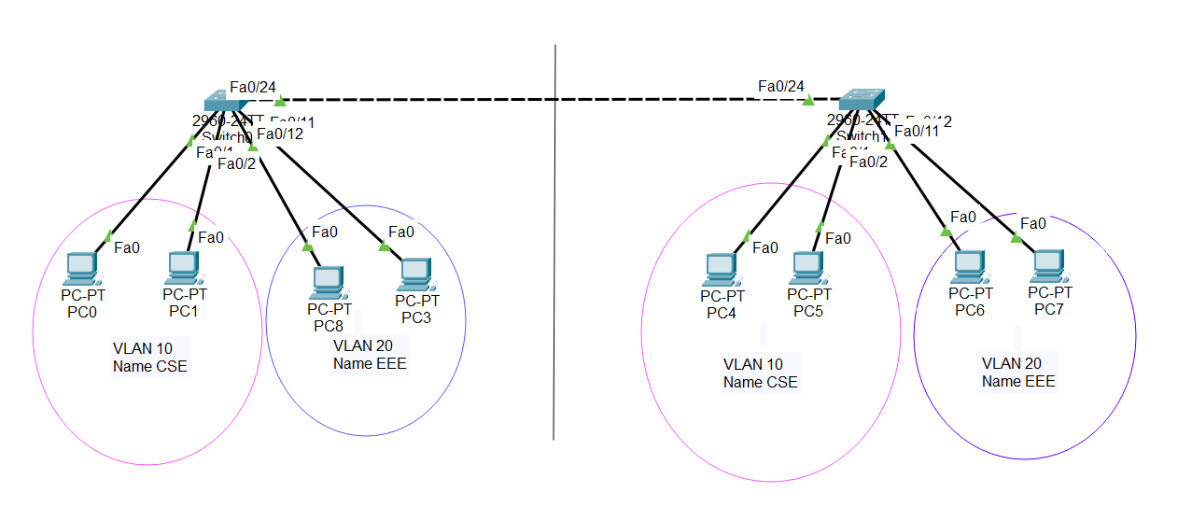

Fig 8.1: VLAN Configured in Cisco Packet Tracer

